

**ART INVASION PROJECT**

# User Implementation Document for Art Invasion Gallery Management System

**1. Introduction**

**1.1 Purpose:**  
This document provides instructions for users on how to implement and operate the **Art Invasion Gallery Management System**. It is intended for both **Admin** and **User** roles to understand their respective features, functionalities, and how to efficiently use the system.

**1.2 Audience:**  
The document is intended for the following:

* **Admin Users** (responsible for managing art types, mediums, products, and enquiries).
* **End Users** (interested in browsing art products and submitting enquiries).
* **Technical Team** (for maintaining the system and troubleshooting issues).

**2. System Overview**

**2.1 Description:**  
The **Art Invasion Gallery Management System** is an online platform built using **PHP** and **MySQL**. The system provides functionalities for managing art products, art types, and handling user enquiries. The platform has two main roles:

* **Admin:** Manages the backend of the platform (art types, art mediums, products, and enquiries).
* **User:** Browses art products and submits enquiries.

**2.2 Key Features:**

* **Admin Module:** Dashboard, Art Type management, Art Medium management, Art Product management, Enquiry handling.
* **User Module:** Art browsing and enquiry submission.

**3. System Requirements**

* **PHP:** Version 7.x or higher.
* **MySQL Database:** Version 5.x.
* **Web Browser:** Mozilla Firefox, Google Chrome, Internet Explorer 8 (or higher), Opera.
* **Server:** XAMPP or equivalent.

**4. Installation and Setup**

**4.1 Prerequisites:**  
Before setting up the system, ensure you have the following installed:

* **XAMPP** or another PHP server environment.
* **MySQL** for database management.
* A modern **web browser**.

**4.2 Steps to Install:**

1. **Download XAMPP** from the official website (https://www.apachefriends.org/index.html).
2. **Install XAMPP** and start the Apache and MySQL services.
3. **Download the Art Invasion Gallery Management System** code.
4. **Extract** the downloaded folder to the htdocs directory of your XAMPP installation.
5. **Set up the database**:
   * Open phpMyAdmin (usually accessible at http://localhost/phpmyadmin).
   * Create a new database named agmsdb.
   * Import the provided SQL file to set up the required tables and data.

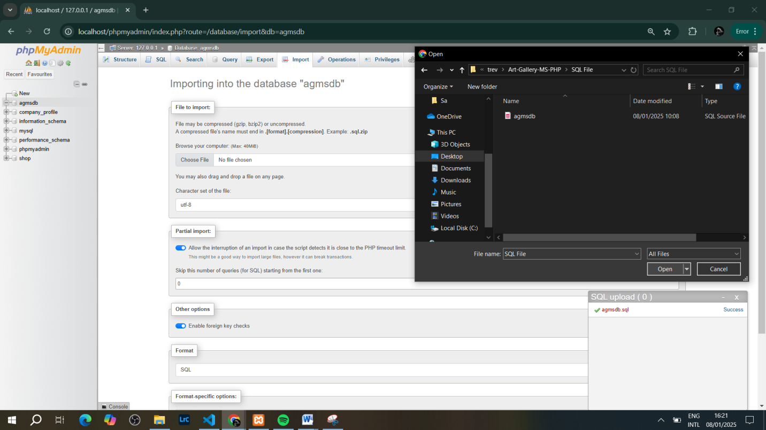

**5. Admin Module Instructions**

**5.1 Admin Dashboard Overview:**

The admin dashboard provides an overview of important metrics such as the number of artists, art types, mediums, products, and user enquiries.  
To access the admin dashboard:

1. Open the web browser and go to http://localhost/art-invasion/agms/admin/login.php
2. Log in with the **admin credentials**

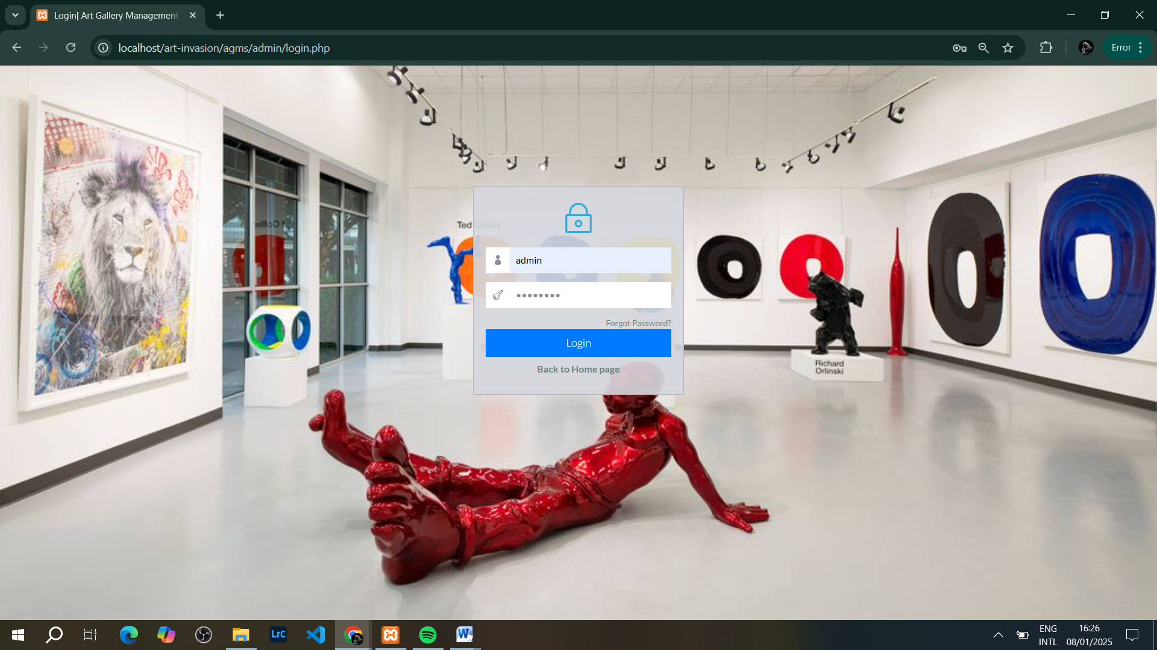

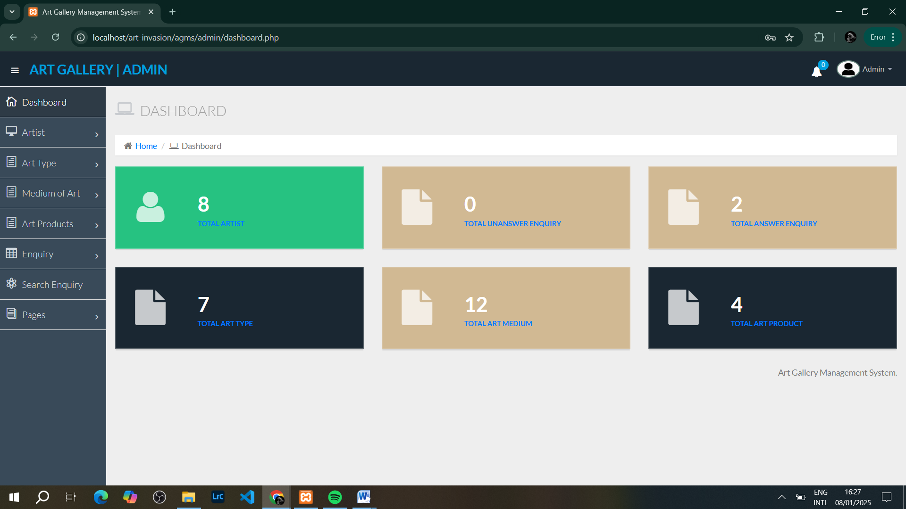

**5.2 Managing Art Types:**

Admin can add, edit, or delete art types (e.g., Paintings, Sculptures, Digital Art).

* To add a new art type:
  1. From the Admin Dashboard, go to the **Art Type** section.
  2. Click **Add Art Type**.
  3. Enter the name of the art type and click **Submit**.

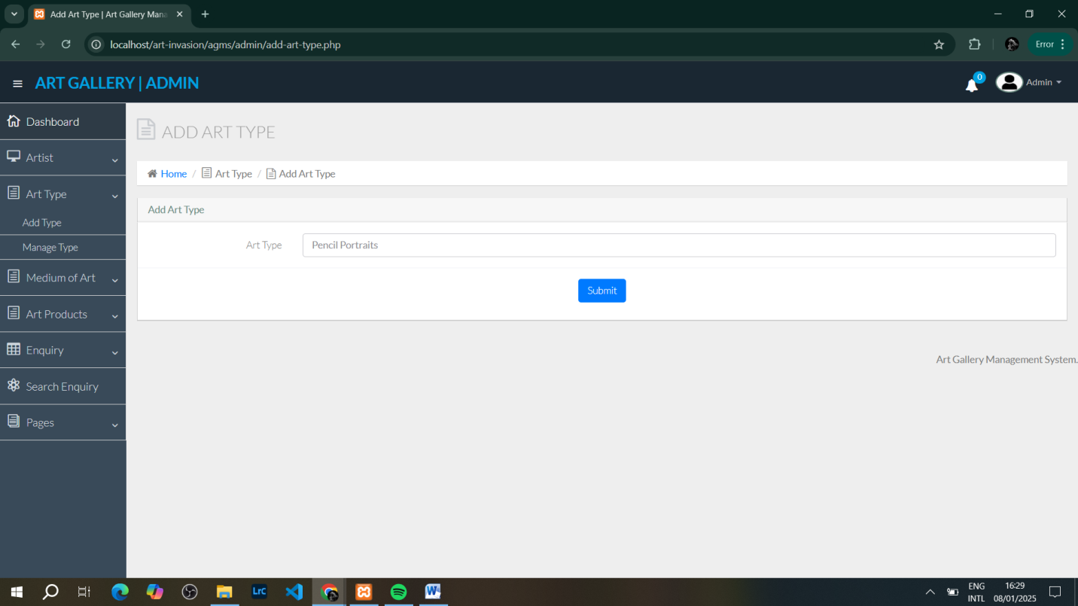

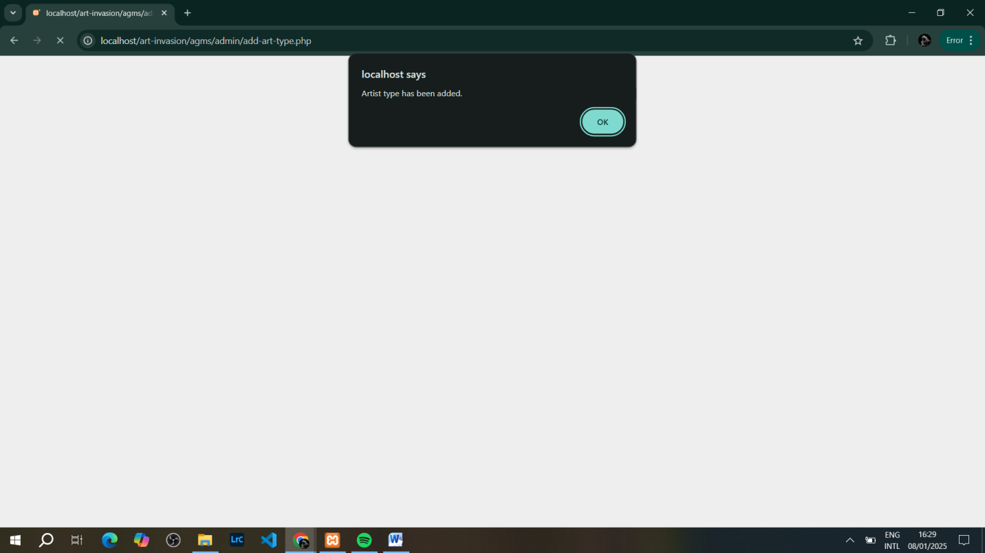

**5.3 Managing Art Mediums:**

Admin can manage different mediums (e.g., Oil, Acrylic, Watercolor).

* To add a new medium:
  1. Go to the **Art Medium** section.
  2. Click **Add Medium**.
  3. Enter the medium name and save.

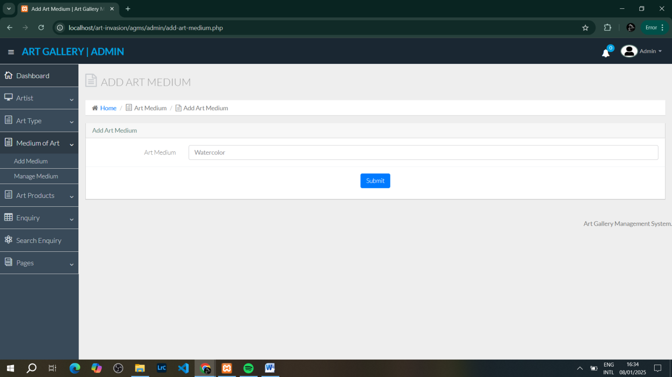

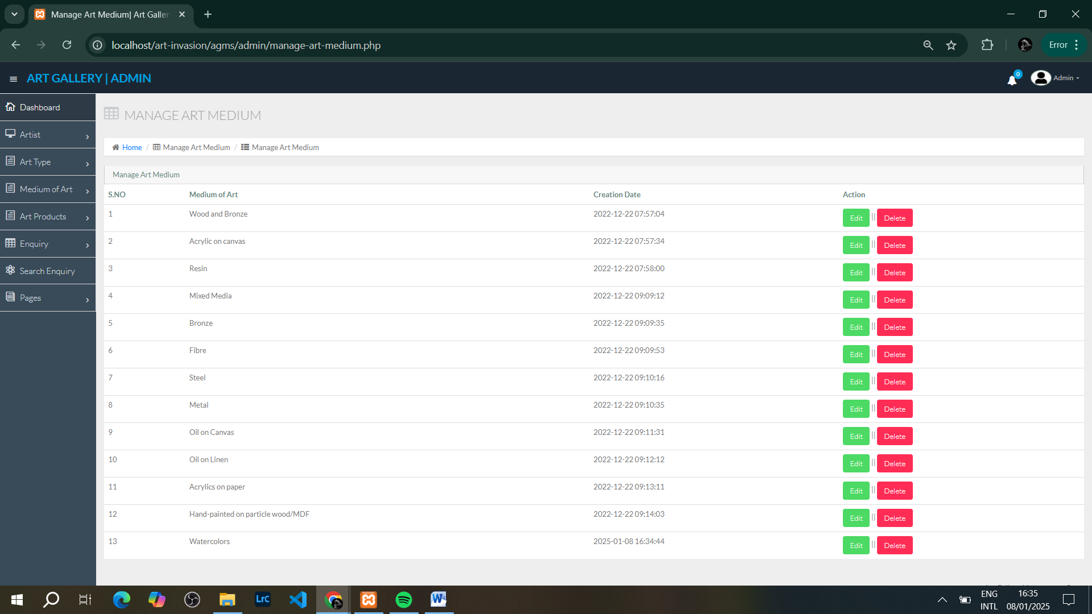

**5.4 Managing Art Products:**

Admin can add, update, or delete art products listed on the platform.

* To add a new art product:
  1. Go to **Art Product** section.
  2. Click **Add Product**.
  3. Fill in the details such as title, description, price, and select the art type and medium.
  4. Upload an image for the product and click **Save**.

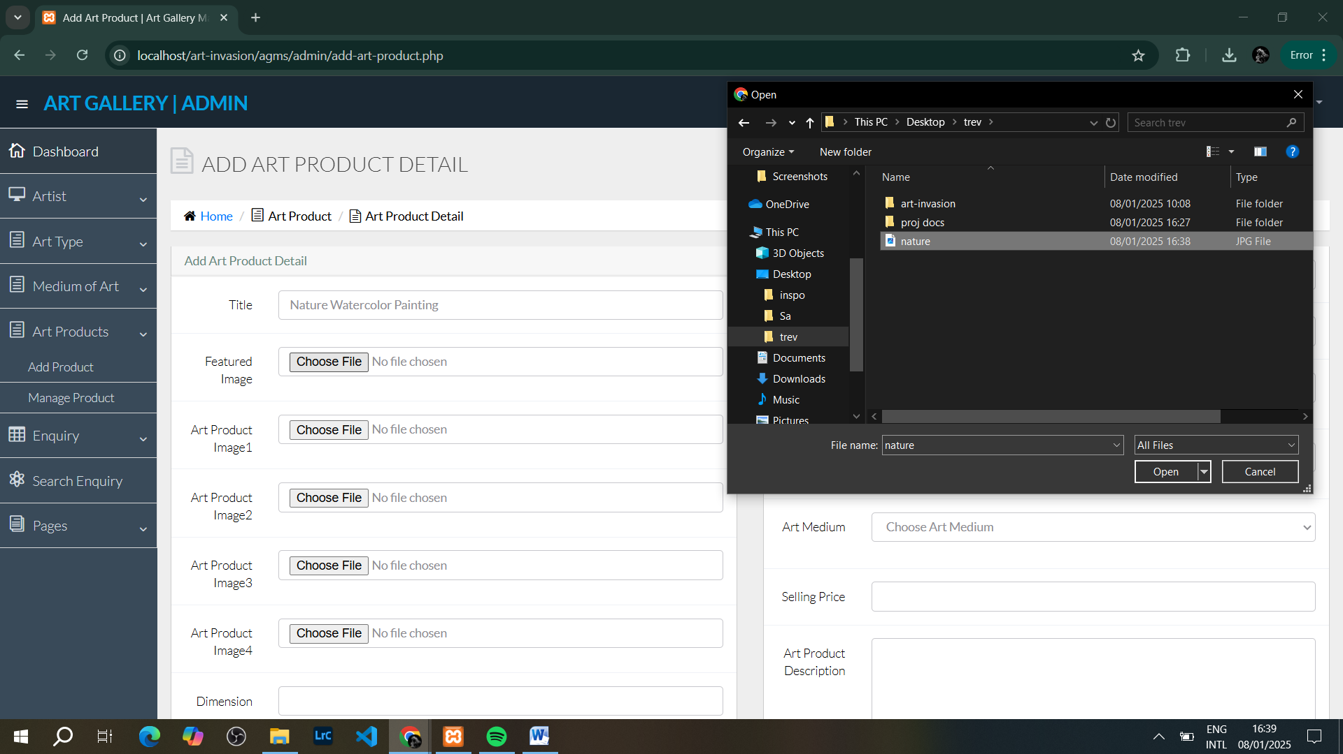

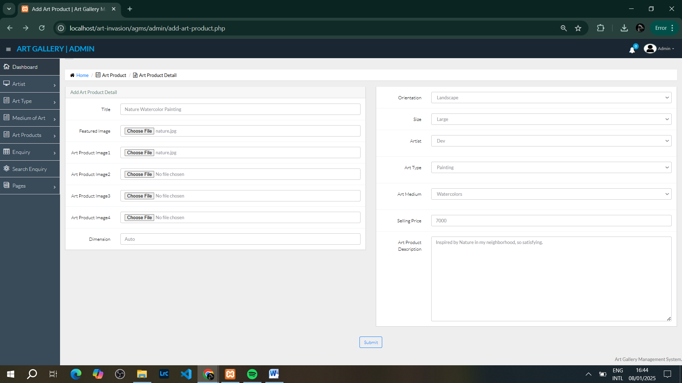

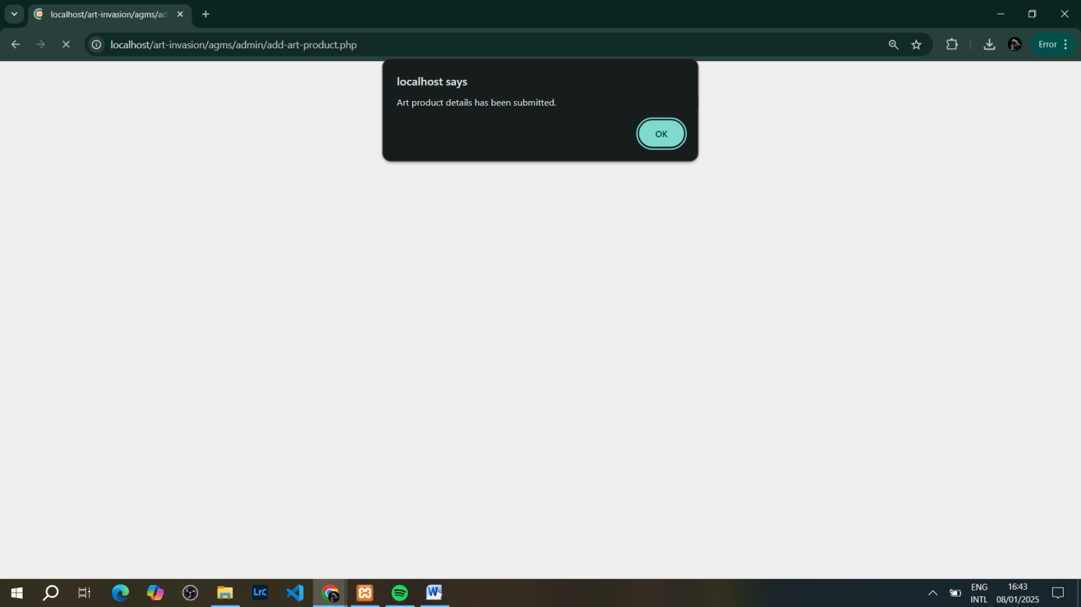

**5.5 Handling User Enquiries:**

Admin can view and manage user enquiries.

* To view enquiries:
  1. Navigate to the **Enquiry** section.
  2. Click on the enquiry number to view the details.
  3. You can mark enquiries as answered or delete them as needed.

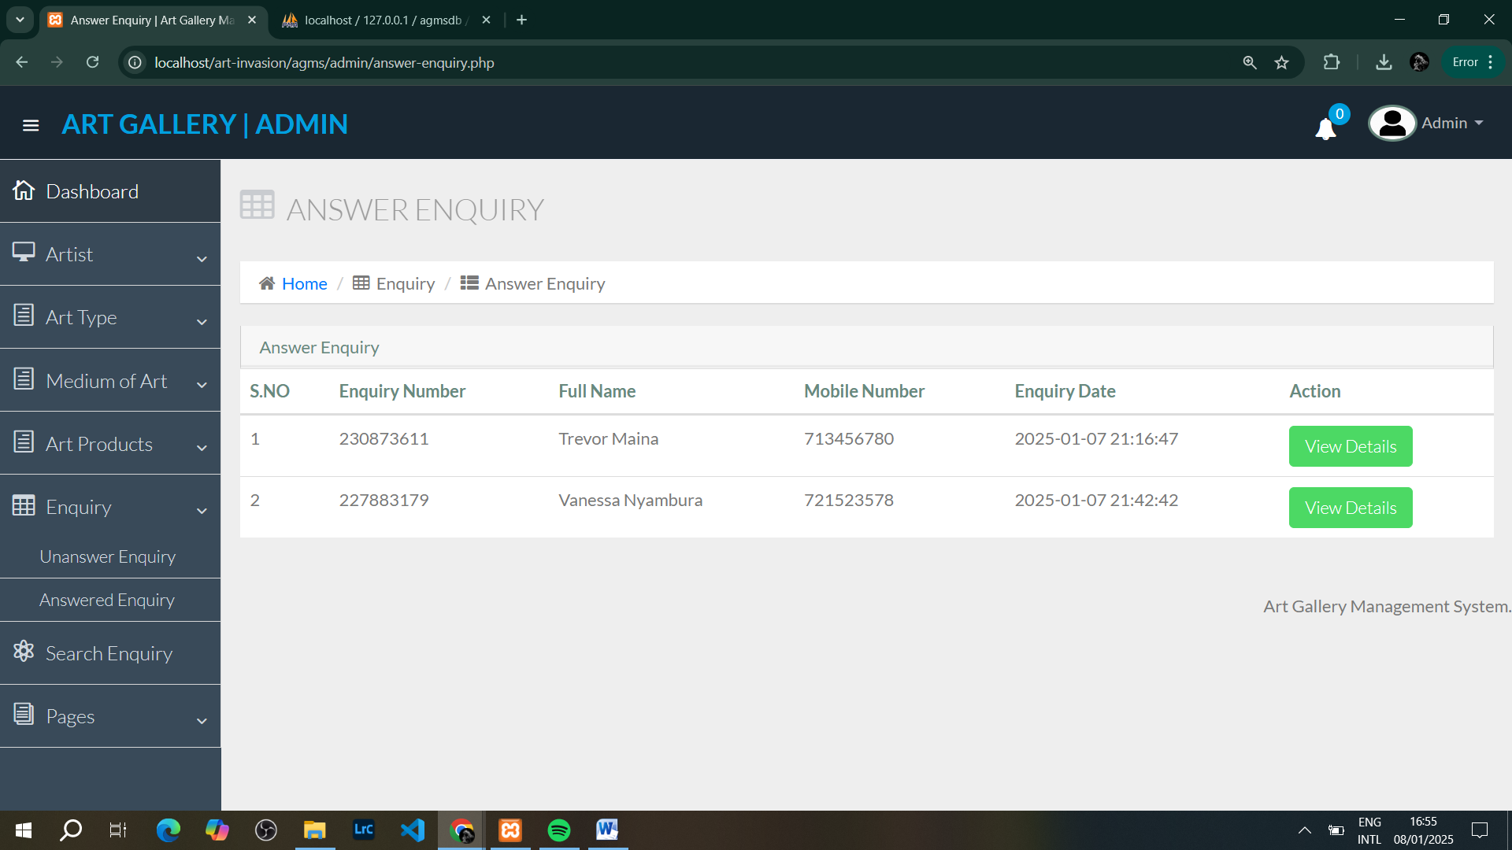

**5.6 Managing Pages:**

Admin can update the About Us and Contact Us pages.

* To edit a page:
  1. Go to the **Page** section.
  2. Select **Edit About Us** or **Edit Contact Us**.
  3. Update the content and click **Save**.

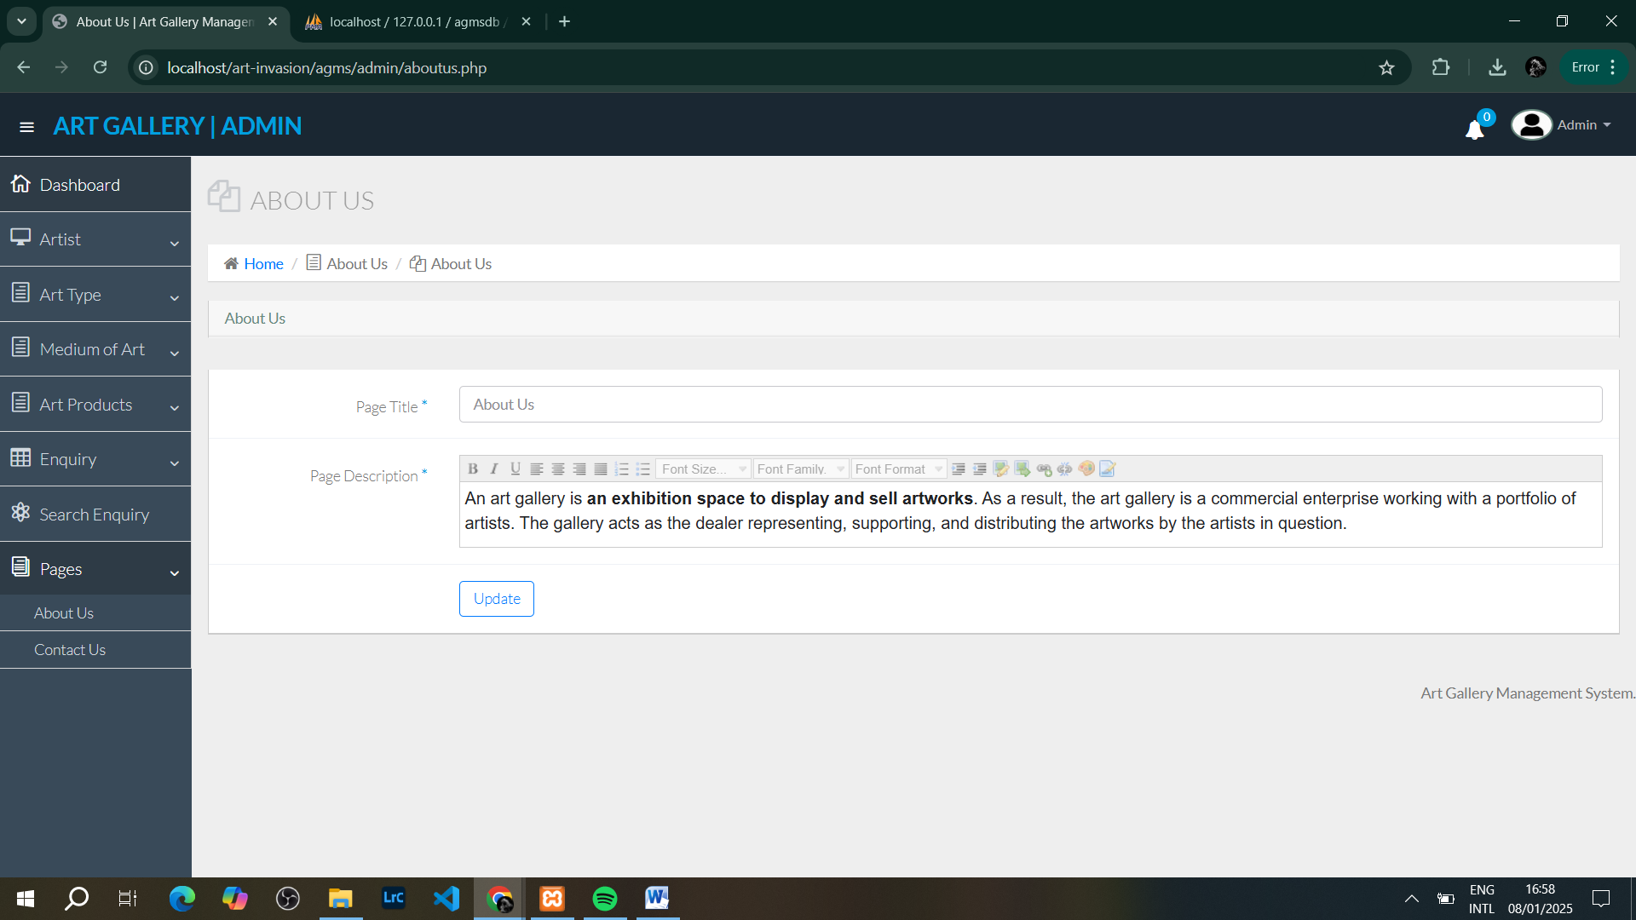

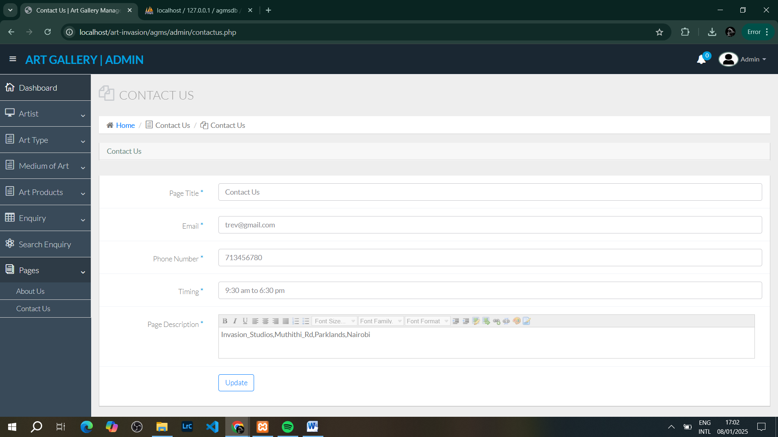

**6. User Module Instructions**

**6.1 Home Page Overview:**

* The Home page serves as the welcome page for users. Here, users can browse various art products based on art type and medium.

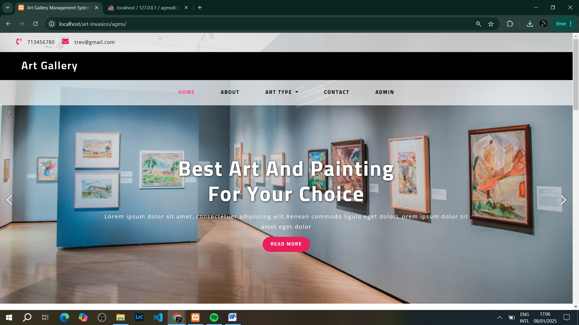

**6.2 Browsing Art Types:**

Users can view art products filtered by different types.

* To view art types:
  1. On the Home page, click on the **Art Type** menu.
  2. Select an art type (e.g., Paintings, Sculptures).
  3. The system will display all products under that type.

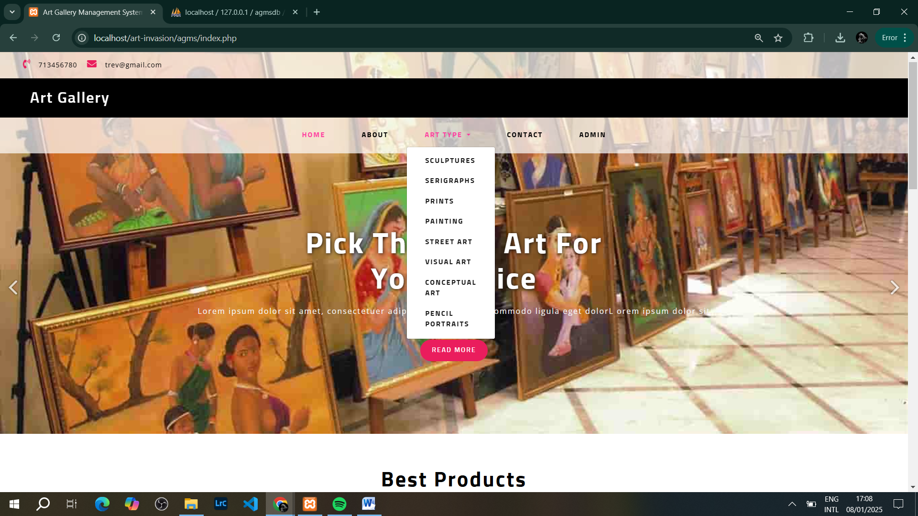

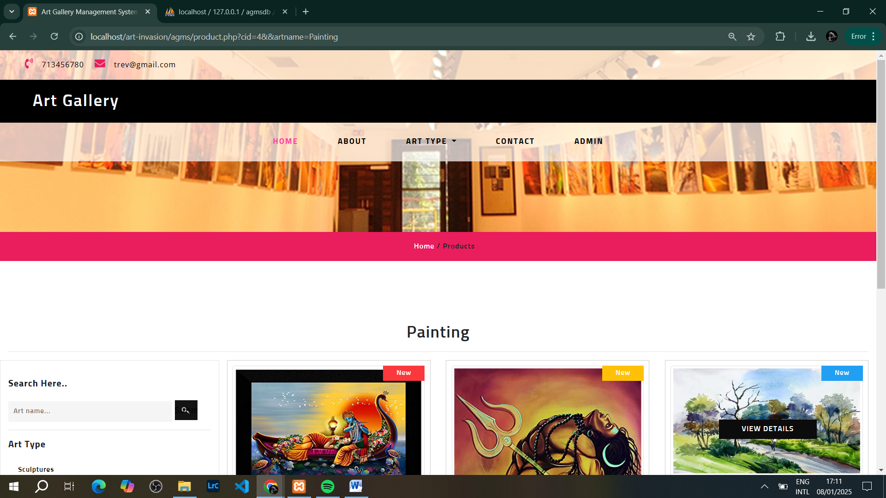

**6.3 Viewing Art Products:**

Users can view the details of a selected art product.

* To view a product:
  1. Click on any art product listed under the art type.
  2. The product details page will show a larger image, description, and price.

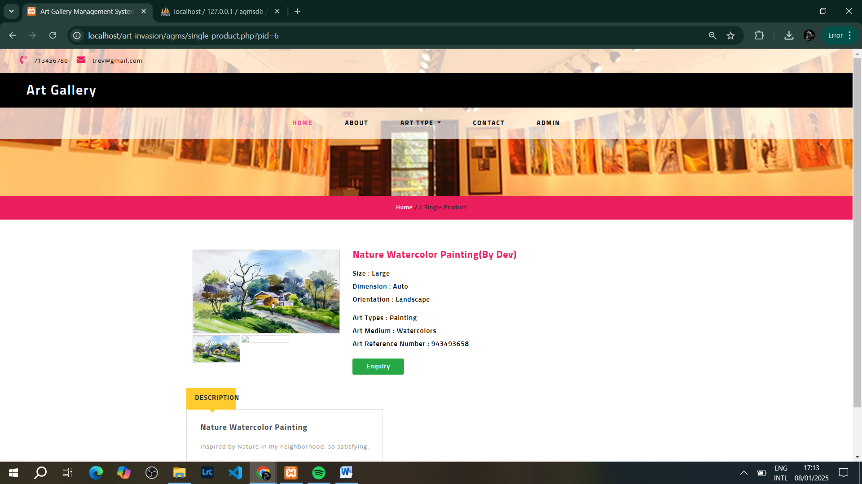

**6.4 Submitting an Enquiry:**

Users can submit an enquiry about a product they are interested in.

* To submit an enquiry:
  1. On the art product details page, click **Submit Enquiry**.
  2. Fill in your name, email, and message.
  3. Click **Send Enquiry**.

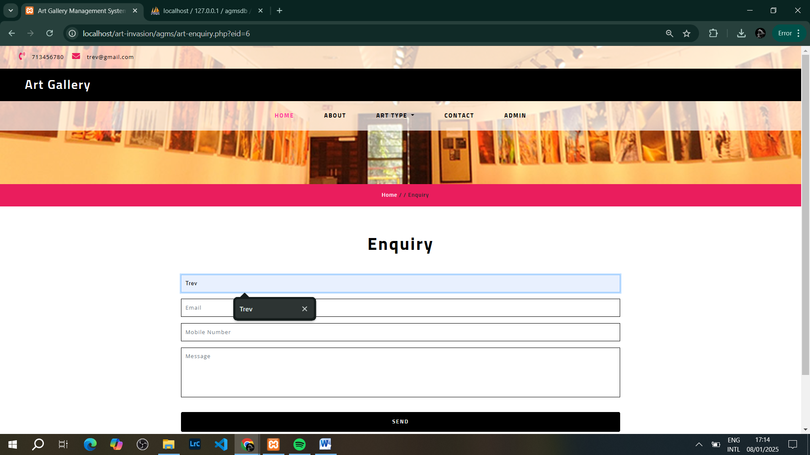

**7. Troubleshooting**

**7.1 Common Issues and Solutions:**

* **Issue:** “Cannot connect to the database.”
  + **Solution:** Ensure MySQL is running in XAMPP and the correct database credentials are configured in the config.php file.
* **Issue:** "Page not loading."
  + **Solution:** Check if Apache and MySQL are running in XAMPP, and verify the file path for the application.

**8. Appendix**

**8.1 Code Snippets:**

* **Database Connection Example (dbconnection.php):**
* <?php
* $con=mysqli_connect("localhost", "root", "", "agmsdb");
* if(mysqli_connect_errno()){
* echo "Connection Fail".mysqli_connect_error();
* }
* ?>

**8.2 Database Schema:**

Include SQL schema for setting up the database (e.g., agmsdb.sql).

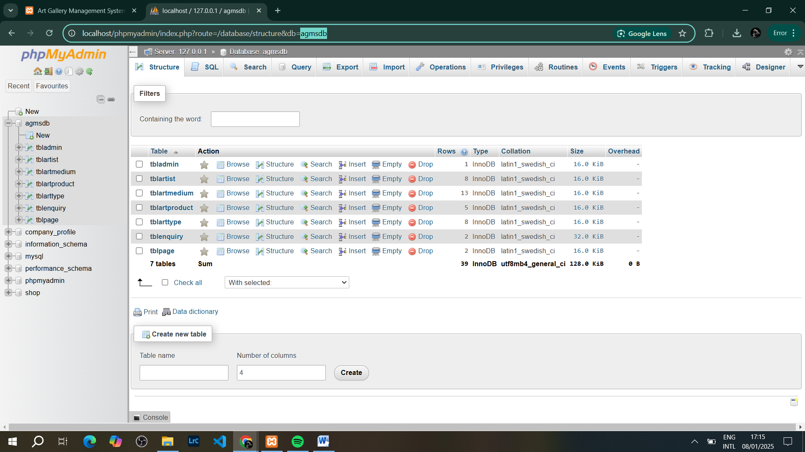

**9. Conclusion**

This **User Implementation Document** serves as a complete guide for both Admins and Users on how to effectively use the **Art Invasion Gallery Management System**. Follow the steps outlined for each module to ensure smooth operation and management of art products, enquiries, and more.